How to install wifilocal.jandenul.com certificate
1 Introduction 2
2 Prerequisites 2
3 Step-by-step plan 2

Introduction
This manual is intended as guide for configuring the Captive portal certificate

Prerequisites
- Wifilocal.jandenul.com certificate
- Certificate password (RDM)
- Excel list with all locations

Step-by-step plan

- Go to \\JDN-FILE01\ict_new_standard_sites_vessels\Certificate
- Add the vessel to the excel “VesselsWithCert.xlsx”
- Log in to the Aruba/Dell virtual controller
- Go to Security -> Walled Garden -> Whitelist -> New -> *.globalsign.com
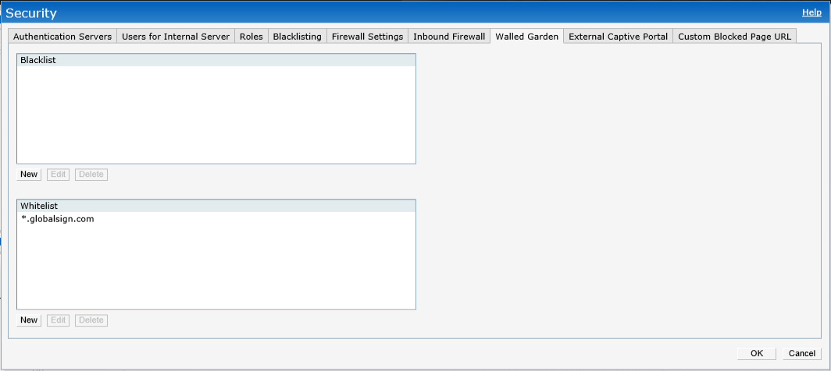
- Go to Maintenance -> Certificates
- Upload the wifilocal.pem certificate & fill in the password (stored in RDM “Aruba/Dell wifilocal pem password”)
